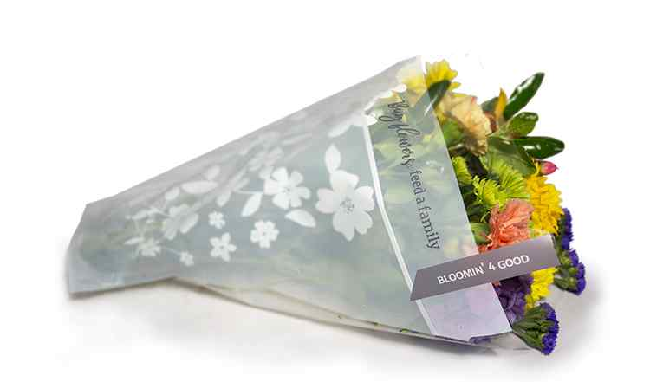

Fact Sheet
BLOOMIN’ 4 GOOD PROGRAM

Congratulations on your organization’s selection in the Stop & Shop Bloomin 4 Good Program!

Not sure how to start talking about the program? We’re here to help! We’ve brought together key facts and talking points from across the program website compiled in one place. Below you will find information you can use to discuss this program with your board, staff, and supporters:
- The Stop & Shop Bloomin’ 4 Good Program has been operating since February 26, 2021.
- Since inception, the program has donated $1,625,249 to 2,624 hunger relief organizations and sold 1,625,249 Bloomin’ 4 Good bouquets.*
- Stop & Shop operates 356 stores across Connecticut, Massachusetts, New Jersey, New York, and Rhode Island that participate in the program.
- Each time a shopper purchases the specially marked $11.99 Bloomin’ 4 Good Bouquet, $1 is donated to a local hunger organization selected to benefit for the month. Every bouquet sold works to fight hunger across the local communities served by Stop & Shop.
- Every month, the Store Leadership Team at each Stop & Shop location chooses a local hunger organization to be the monthlong beneficiary of the Bloomin’ 4 Good Program in that store. Different hunger organizations are selected every month to ensure the many hunger organizations making a difference in our local communities can be supported by this program. The name of the hunger organization is displayed in the floral section during their benefiting month.
- Generally, the hunger organizations selected by a specific store are within a 10-mile radius of that store location. It’s important to note that this program benefits each store’s regional shopping area.
________________________________________
*As of 5.10.25. These statistics are updated daily on the program website and can be found here. You will want to use the most recent data available at the time of your selection.

Page 2
- Each bouquet costs $11.99, with $1 of that purchase going to support a benefiting hunger organization in your community.
- Nonprofits meeting the program's qualifications are submitted to our database of thoroughly researched organizations within the vicinity of each store location
- A list of nonprofit organizations that have benefited from the Bloomin’ 4 Good Program can be found here on the program website and is organized alphabetically.
Published 5.12.2025.

